Introduction to Kubernetes control plane components

We have seen before the components that are in control plane node,
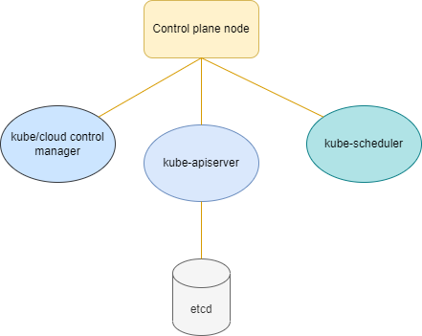

Whereas, kube-scheduler is divided into two major components
- filtering and
- scoring
Similarly kube-control manager has multiple controllers that perform a specific job:
- Node controller
- Job controller
- Endpoint Slice controller
- ServiceAccount controller and many more.

Note: If we are using cloud services to launch our cluster, we have a component called cloud-control manager which is similar to kube-control manager with few additional controllers such as:
- Node controller
- Route controller
- Service controller, etc.

